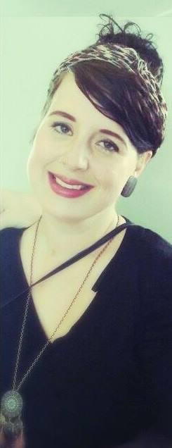
Personal Details:
Name: Malou Nadieh Maria
Surname: Poffers
Date of Birth: 19-07-1992
Nationallity: Dutch
Mobile: +31625526606
E-mail: nadiehmedea@gmail.com
Education:
Deltion College, Zwolle
Degree: Art & Design International
2010 - 2012
Deltion College, Zwolle
Degree: Social Work
2012 – 2014
Courses:
First Aid Diploma Finished February 2013
Assertive Behavior Finished June 2011
Anglia English Language Finished July 2007
Professional experience:
- Volunteer Swimming instructor for kids with special needs
Responsibility: helping children with special needs improving their ability to swim.
Empoleyer: De Waterspetter, Hellendoorn.
July 2008 – July 2009
- Caretaker of Elderly
Responsibility: help with housekeeping, help with preparing/cooking meals, help with eating.
Employer: Zorgaccent, Hellendoorn
2010 - 2012
- Assistant Work Mentor
Responsibility: Supervising staff in Kitchen & Kantine/ Maintaining good quality of food/ Small food preparations/ Personal coaching staff.
Employer: React Twente, Nijverdal
January 2014 – January 2015

- Personal Mentor of Young Adults with special needs
Responsibility: help with personal hygiene, handing out medicine, help with everyday tasks.
Employer: Frion
January 2015 – September 2015
- Au pair
Responsibilitly: taking care of children, light housework
Organization: Travel Active
September 2015 - Present
Skills:
Mastering of Language Dutch - Native speaker
English - Fluent German - Basic communication skills
French - Basic communication skills
Sign Language - Basic communication skills
Knowledge of Computers Office - Very Good
Word - Very Good
Hobby’s and Interests Painting
Drawing
Cooking
Art
Nature
Behavior Psychology

