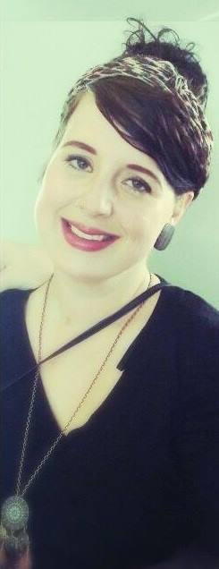
Personal Details:
Name: Malou Nadieh Maria
Surname: Poffers
Date of Birth: 19-07-1992
Nationallity: Dutch
Adres: Kruidenlaan 142
7443 JL Nijverdal
The Netherlands
Mobile: +31625526606
E-mail: nadiehmedea@gmail.com
Education:
Pius X college, Rijssen
HAVO/VWO 3 > 4
2006 - 2010
Deltion College, Zwolle
Degree: Art & Design International
2010 - 2012
Deltion College, Zwolle
Degree: Social Work
2012 – 2014
Courses:
First Aid Diploma Finished February 2013
Assertive Behavior Finished June 2011
Anglia English Language Finished July 2007
Work experience:
- Personal Mentor of Young Adults with special needs
Organization: Frion
Address: Gouverneurlaan 30, Zwolle
Phone Number: +3138 460 67 40
- Assistant Work Mentor for people who fell out of society
(Supervising staff in a kantine/kitchen in order for them to practice a job before going back in society)
Organization: React Twente
Address: Sanatoriamlaan 20, Hellendoorn
Phone Number: +31548 20 01 12
- Volunteer Swimming instructor for Children with special needs
Organization: De Waterspetters
Address: Zwaluwtong 34, Nijverdal
Phone Number: +31 0900-1824
- Au pair
Organization: Travel Active
Address: Postbus 107, Venray
Phone Number: +31 (0)478 551 900

Skills:
Mastering of Language Dutch - Fluently
English - Very Good
German - A little bit
French - A little bit
Sign Language - A little bit
Knowledge of Computers Office - Very Good
Word - Very Good
Hobby’s and Interests Painting
Drawing
Cooking
Art
Nature
Behavior Psychology

